

##### JOY DIOR

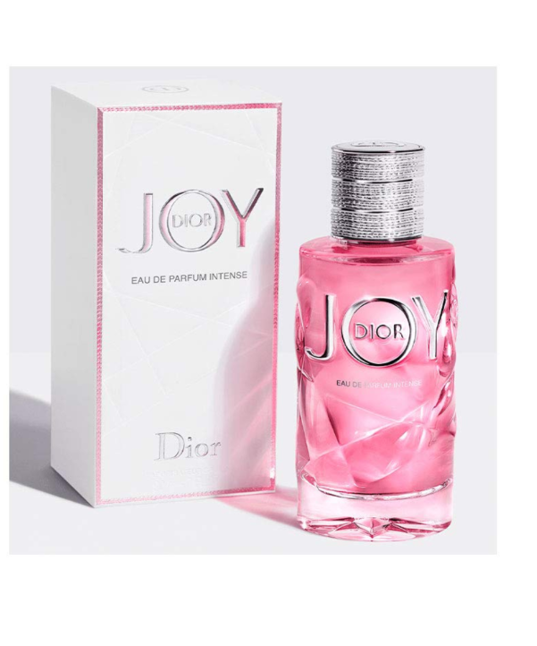A pure concentration of joy in a bottle. JOY by Dior Eau de Parfum is a bright smile. A juicy, vibrant top note gives way to an enveloping white heart of flowers and musks, like a soft caress.

JOY by Dior expresses this remarkable feeling of joy by offering an olfactive interpretation of light.  
  
This perfume resembles certain pointillist paintings that are rich with a precise, yet not too obvious, technique. It is constructed with multiple nuances, a myriad of facets that lead to an expression that is clear and self-evident.  
  
Bringing a new Dior perfume to life is an event. For the entire House, as well as for me. It should rally and delight both women and men.

Its bottle is both luminous and precious. Its femininity shines through in the brilliant silver and radiant pink of this instantly attractive juice.  
A bright shining silver thread wraps around the lid, like a light jewel delicately engraved with its name, which curls around in a perfect O.  
Sparkling, tangible joy, literally nestled at the beating heart of Dior.